**Tarea 2**

**Oscar Hernández – 1088321**

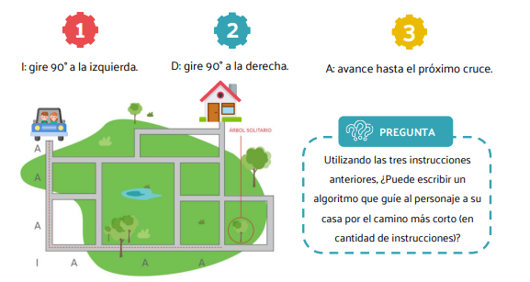



**Algoritmo 1: AIAAAAIAA**

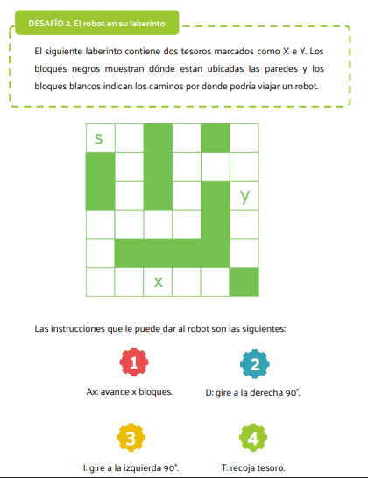

**Tesoro Y: A1, D, A3, I, A2, I, A2, D, A2, D, AI, T**